**PHARMACY MANAGEMENT SYSTEM**

**UIT2211 – SOFTWARE DEVELOPMENT PROJECT – I**

**A PROJECT REPORT**

***Submitted by***

**BALAKUMAR G - 3122215002019**

**BHARATH KUMAR G- 3122215002020**

**BHUVANESWARRAN T- 3122215002021**

**DARRIEN XAVIER PV- 3122215002022**

**DEEPESH SUDHAN A- 31221215002023**

**DENNIS ANDREW B -3122215002024**

**DHANUSHPRIYAN P -3122215002025**

**SSN COLLEGE OF ENGINEERING,**

**KALAVAKKAM**

**AUGUST 2022**

**Sri Sivasubramaniya Nadar College of Engineering**

**(An Autonomous Institution, Affiliated to Anna University)**

**BONAFIDE CERTIFICATE**

**Certified that this project titled PHARMACY MANAGEMENT SYSTEM is the bonafide work of BALAKUMAR.G -3122215002019, BHARATH KUMAR.G -3122215002020, BHUVANESWARRAN.T -3122215002021, DARRIEN XAVIER.P V-3122215002022, DEEPESH SUDHAN A-3122215002023, DENNIS ANDREW B-3122215002024, DHANUSHPRIYAN P-3122215002025 and is submitted for project viva-voce examination held on 25 August 2022.**

**Signature of examiner(s)**

**ABSTRACT**

**PROBLEM DESCRIPTION :**

A small pharmacy wants to develop a system to maintain their stock of medicines and track the daily sales. A salesperson should be able to input the required medicines from a prescription and generate an invoice for the same. The system should indicate to the salesperson the bins where each required medicine is available. The management should be able to track their daily/weekly/monthly/annual sales and stock. The system should generate alerts when a medicine is about to expire. Alerts should be generated when a medicine is going to be out of stock.

**MOTIVATION**:

The pharmacy management system is built for effective management of pharmacy. This system is time efficient and all data can be accessed in constant time. This system is designed with a better GUI and also to generate statistical reports when compared to existing systems.

**OBJECTIVES:**

* Improve performance and efficiency of a pharmacy
* Provide easy access to sales and stock reports
* Provide easy access of printing invoices for customers
* To minimize human errors
* High degree of minimization of time and resources
* To design a system that is better than manual recording system
* To design a system that can keep and track of medicines

**CLIENT DESCRIPTION:**

**Client’s Pharmacy : SRI SARAVANA PHARMACY**

The client needed the system to generate invoice , to track stock and sales, and also to generate alerts when the medicines are about to expire

**INTRODUCTION:**

**MOTIVATION:**

The project is developed using Python language and using Hashtable as it is Data Structure.The pharmacy management system is developed with an initiative of giving medicine details of the medicines when name is entered. The system is also designed user friendly and also performs tasks in quickest time.

**PROBLEM STATEMENT:**

A small pharmacy wants to develop a system to maintain their stock of medicines and track their daily lives. A salesperson requires the following functions - input medicines, generate invoice, bins location, track sales, alert medicines when expired or out of stock.

**PROJECT OBJECTIVES:**

The user-friendly software reduces the burden for Pharmacists and helps in managing the tasks in Pharmacy like Billing, Alerts, Reports etc. also improving the processing efficiency. It supports fast and efficient searching and updating medicines. It supports generating reports in an easier way and the user-interface is also very handy , easy to use for anybody who has basic knowledge of computers, also improving the accuracy of the system.

**DELIVERABLES:**

**PROJECT NAME:** PHARMACY MANAGEMENT SYSTEM

**PROJECT STATUS:** COMPLETED

| **S.NO** | **DELIVERABLE**  **NAME** | **DESCRIPTION** | **STATUS** |
| --- | --- | --- | --- |
| 1 | INVENTORY | Initial UI design for dashboard | COMPLETED |
| 2 | REPORTS | Final window design for daily statistics | COMPLETED |
| 3 | ALERTS | Window displaying medicines shortage and expired | COMPLETED |
| 4 | INVOICE | Design/Format for bill/invoice generation | COMPLETED |
| 5 | PMS APPLICATION | Fully developed final application with bug fixes | COMPLETED |

**REQUIREMENT ENGINEERING:**

**CLIENT DETAILS:**

**CLIENT NAME:** Sri Saravana Pharmacy

**CLIENT LOCATION:** No.1/248,Mariamman Temple Street, Mugalivakkam Main Road, Chennai-600125

**PHARMACY OWNER**: Muthu

**CLIENT CONTACT:** 044 2252 3525

**FUNCTIONAL MODULES:**

* Storing available stock and information temporarily.
* Generating invoice depending on user’s requirement.
* Providing statistics about daily,weekly ,monthly and annual sales.
* Generating alerts when medicine is about to expire.
* Alerting when medicine is about to go out of stock

| **SPRINT** | **Epic** | **User story#** | **Requirement /user story** | **Essential or desirable** | **Description of the requirement** | **Remarks** |
| --- | --- | --- | --- | --- | --- | --- |
| 2 | Stock and Track | 1 | As a pharmacist, I want the system developed to maintain the stock of medicines and track the sales. | Essential | Developing a software which can keep track of the whole stock of medicines available and also make a report and track the sales. | Hashtable is being used to keep data related to medicines |
| 1 | Expire alerts | 2 | I also want the system to raise an indication when medicines about to expire and going out of stock | Essential | The software should be able to generate alerts whenever a medicine is getting expired or out of stock . | Datetime module in Python time is used for extracting present date |
| 1 | Invoice | 3 | I want my salesperson to be able to input the required medicines and generate invoice. | Essential | The software should be able to generate an invoice after the customer buys the required medicines. | Text File is being used to generate invoice |
| 1 | Statistics | 4 | I want the system to track daily, weekly, monthly, annual sales and stocks. | Desirable | Tracking the whole sales daily , weekly,monthly and annually. | Matplotlib module is used to display reports as bar graphs |

**USER ACCEPTANCE TESTING**

| **Number** | **Acceptance Requirement** | **Critical**  **(Yes/No)** | **Test Result**  **(Accept/Reject)** | **Comments** |
| --- | --- | --- | --- | --- |
| 1. | Correct medicine names should be entered. | Yes | Accepted | The invoice will not be generated until this requirement has been met. |
| 2. | Medicines which are expired must be displayed | Yes | Accepted | Medicines expired will be displayed in a separate window |
| 3 | Medicines are only delivered when it is within quantity range | Yes | Accepted | Error message is generated when quantity is not satisfied |
| 4 | Medicines names are not case sensitive | No | Accepted | Error message is generated if this requirement is not satisfied |
| 5 | Invoice and reports are not generated until purchase is not complete | Yes | Accepted | Empty window is generated if this requirement is not satisfied |

**IMPLEMENTATION AND RISK MANAGEMENT**

**Name of the student: Balakumar G**

**Register number: 3122215002019**

**Role in the project: LEAD DEVELOPER**

1. **Implementation**

| **Sprint#** | **Epic** | **User story#** | **Requirement/User story** | **Remarks on implementation** |
| --- | --- | --- | --- | --- |
| 2 | Creating a database | 1 | As a user I want to keep hold of the information related to the medicine | Hashtable data structure  is implemented to store data |

**b. Risk Management**

| **Risk #** | **Risk description** | **Probability** | **Impact** | **Mitigation plan** |
| --- | --- | --- | --- | --- |
| 1 | Taking too much time to retrieve  Information about medicine | HIGH | It would slow down the entire process which depends on the  hashtable | Using a hashtable as it has a amortized time complexity of O(1) for access |

**Name of the student: Bharath Kumar G**

**Register number: 3122215002020**

**Role in the project: DEVELOPER**

1. **Implementation**

| **Sprint#** | **Epic** | **User story#** | **Requirement/User story** | **Remarks on implementation** |
| --- | --- | --- | --- | --- |
| 1 | INVOICE | 1 | After the customer buys the medicines, invoice should be generated. | Text File is used for generating invoice |

1. **Risk Management**

| **Risk #** | **Risk description** | **Probability** | **Impact** | **Mitigation plan** |
| --- | --- | --- | --- | --- |
| 1 | Wrong medicine name and quantity to be printed in the invoice | LOW | Incorrect details provided to the customer | Proper checks are made before writing onto the text file invoice |

**Name of the student: Bhuvaneswarran T**

**Register number: 3122215002021**

**Role in the project: SCRUM MASTER**

**a.Implementation**

| **Sprint#** | **Epic** | **User story#** | **Requirement/User story** | **Remarks on implementation** |
| --- | --- | --- | --- | --- |
| 2 | Creating a database | 1 | As a user I want to check if the medicine required by the customer is currently available. | Created a member function inside the hash table which provide the keys and values i,e medicine name and its related information. |

**b.Risk Management**

| **Risk #** | **Risk description** | **Probability** | **Impact** | **Mitigation plan** |
| --- | --- | --- | --- | --- |
| 1 | Adding medicines after Hashtable is filled must not generate an error | HIGH | The user won’t be able to add new medicines once the hash table is filled | Separate chaining is being used to avoid maximum number of collisions and to store many quantity of medicines |

**Name of the student: Darrien Xavier P V**

**Register number: 3122215002022**

**Role in the project: DEVELOPER**

1. **Implementation**

| **Sprint#** | **Epic** | **User story#** | **Requirement/User story** | **Remarks on implementation** |
| --- | --- | --- | --- | --- |
| 1 | Statistics | 4 | As a user, I need to receive a statistical report for tracking sales in a daily fashion | Matplotlib module in Python is being used to generate bar graph of sales |

1. **Risk Management**

| **Risk #** | **Risk description** | **Probability** | **Impact** | **Mitigation plan** |
| --- | --- | --- | --- | --- |
| 1 | Entry of large amounts of data leads to data cluster | LOW | It might lead to creating a wrong statistical report and make it in a | Instead of using bar graph,pie chart is being used |

**Name of the student: DEEPESH SUDHAN A**

**Register number: 3122215002023**

**Role in the project: DEVELOP ER**

1. **Implementation**

| **Sprint#** | **Epic** | **User story#** | **Requirement/User story** | **Remarks on implementation** |
| --- | --- | --- | --- | --- |
| 1 | Alerts | 1 | Generate alerts when the medicines are about to expire or when there is shortage of medicine | Datetime module in Python is being used to generate alerts based on today’s date |

1. **Risk Management**

| **Risk #** | **Risk description** | **Probability** | **Impact** | **Mitigation plan** |
| --- | --- | --- | --- | --- |
| 1 | Medicines which are not expired may be considered as expired | HIGH | Expired medicines may lead to wrong medication | Datetime module is used from Python to avoid such risks |

**Name of the student: Dennis Andrew B**

**Register number: 3122215002024**

**Role in the project: PRODUCT OWNER**

1. **Implementation**

| **Sprint#** | **Epic** | **User story#** | **Requirement/User story** | **Remarks on implementation** |
| --- | --- | --- | --- | --- |
| 1 | Inventory | 1 | As a user, I should be able to add medicines to the bill | Implemented using tkinter entry boxes and buttons in a user-friendly manner. |
| 1 | Inventory | 2 | As a user, I should know the location of the added medicines using bin number | Used HashTable to look up bin number of medicine and display it. |

1. **Risk Management**

| **Risk #** | **Risk description** | **Probability** | **Impact** | **Mitigation plan** |
| --- | --- | --- | --- | --- |
| 1 | Expired/Out of stock medicines can be displayed | HIGH | Will pose a serious threat to the patient. | Alert users regarding expired/out of stock medicines. |

**Name of the student: Dhanushpriyan P**

**Register number: 3122215002025**

**Role in the project: Tester**

**TEST LOG REPORT**

| **TC ID** | **TEST CASE DESCRIPTION/CONDITION** | **INPUT** | **EXPECTED OUTPUT** | **RESULT**  **(PASS/FAIL)** |
| --- | --- | --- | --- | --- |
| 1. | If we enter the negative value for the medicine quantity | -5 | Invalid entry. Try again | FAIL |
| 2. | If medicine quantity is less than 5 | Getting maximum possible medicine quantity | Medicine should be added to shortage list | PASS |
| 3. | Buying expired medicine | Paracetamol | Sorry medicine is expired | FAIL |
| 4. | If we enter the medicine quantity greater than the available quantity | 500 | Sorry the asked quantity is not available | PASS |
| 5. | If no medicine is entered | No input | No medicine is entered. Try again | PASS |
| 6. | Entering invalid inputs for medicine quantity like decimal numbers | 2.5 | Invalid entry. Try again | FAIL |
| 7. | If no medicines are added to the bill in inventory | Message box displaying no added medicines | Message box is successfully displayed | PASS |
| 8. | If no medicines are added to the bill in inventory for statistics. | Message box displaying no added medicines | Message box is successfully displayed | PASS |
| 9. | Getting quantity for expired medicines . | No input | Sorry <medicine name> not available | FAIL |
| 10. | Bin number for the medicines should be displayed | dolo | 4 | PASS |

**Project Management:**

**SPRINT 1:** Sprint 1 comprises Inventory, Alerts, Statistics modules

**BURNUP CHART:**

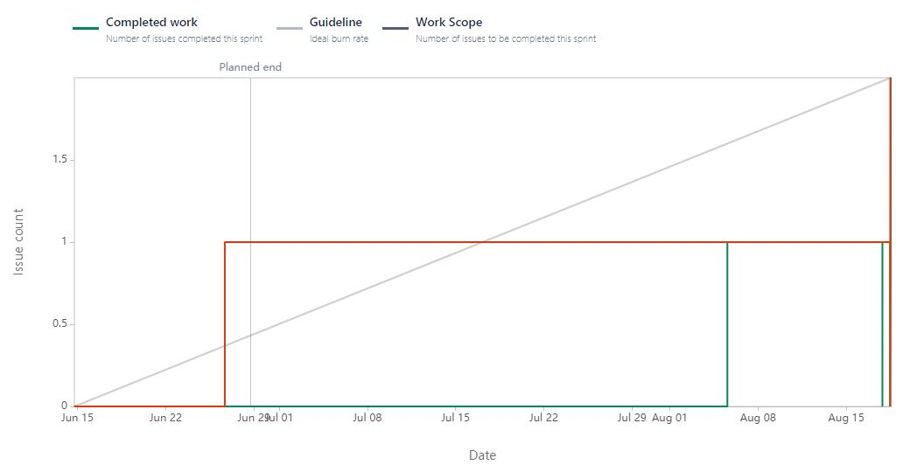

**BURNDOWN CHART:**

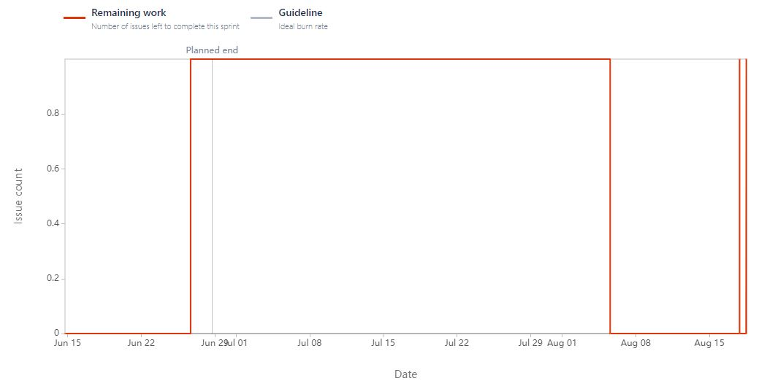

**SPRINT 2** : Sprint 2 comprises Data structure(Hash table) -Backend Module

**BURNUP CHART:**

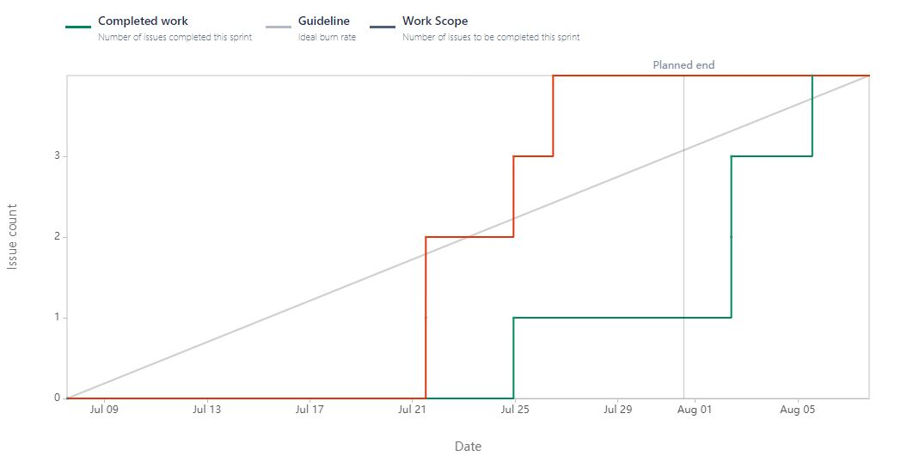

**BURNDOWN CHART:**

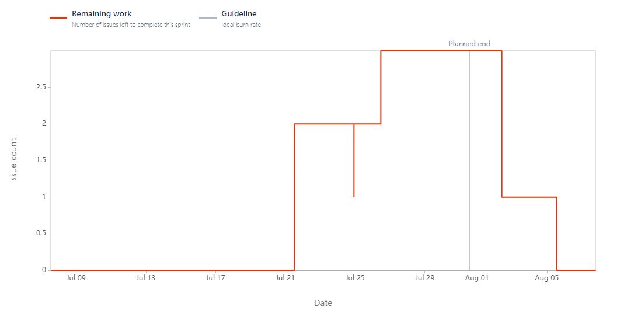

**Generated From JIRA Tools:**

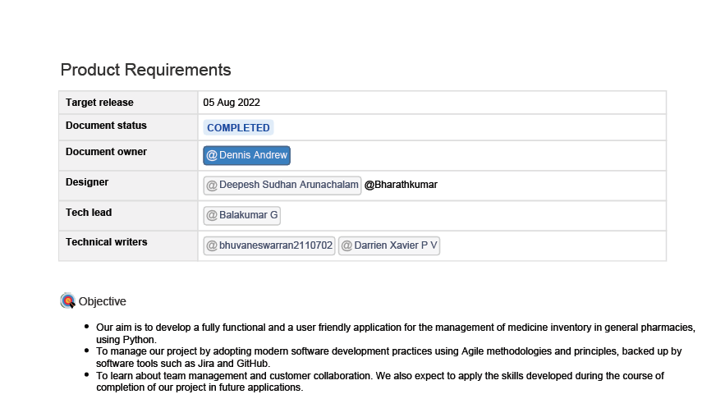

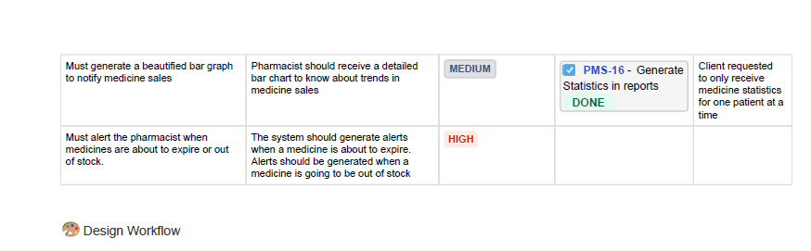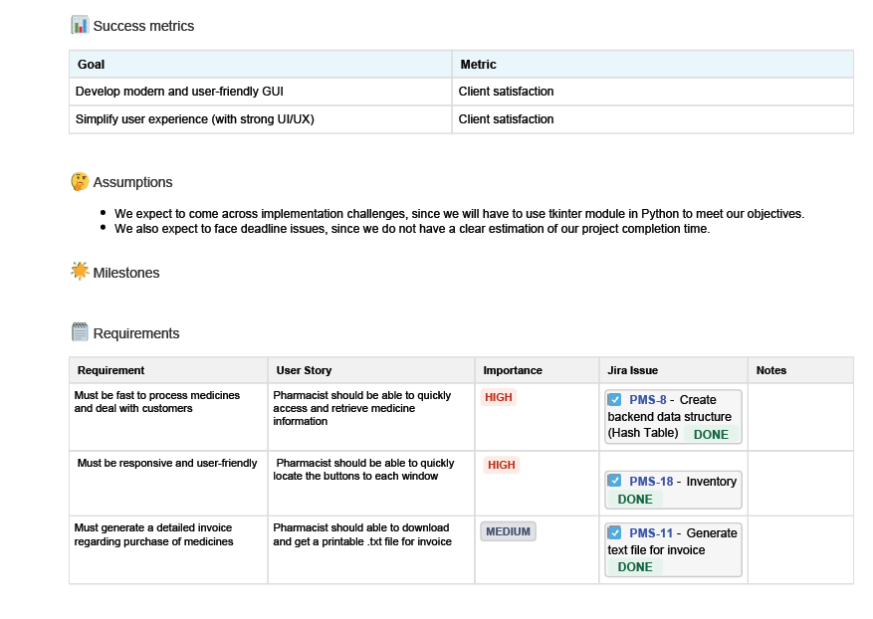

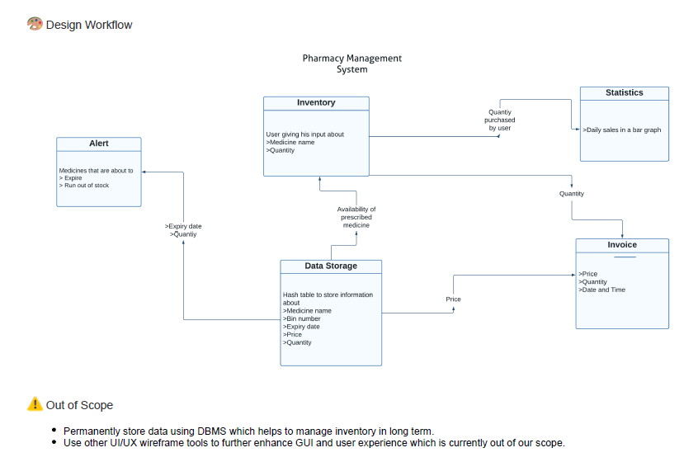

**MEETING NOTES:**

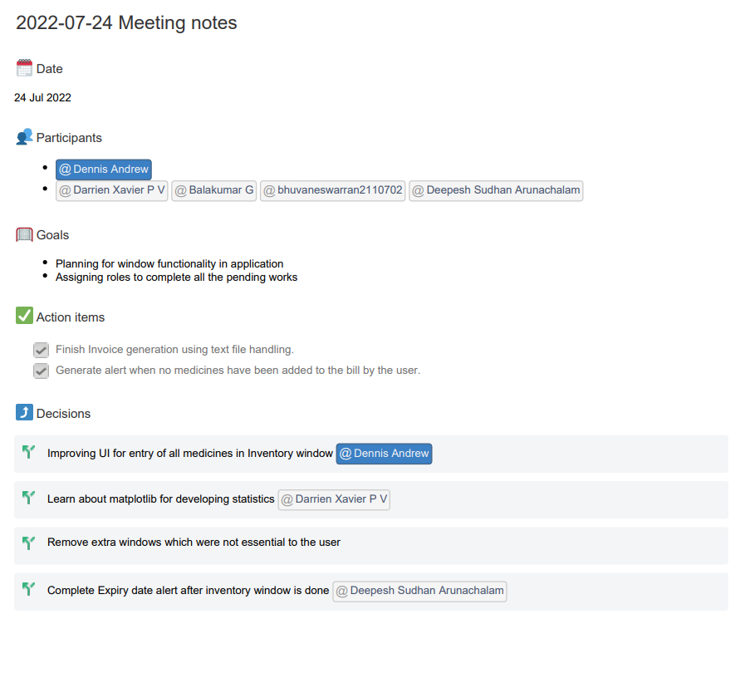

**Project Outcomes:**

**Code snippets:**

#1 Getting input from the user:

* E_med is an entry box which receives the name of the medicine from the user

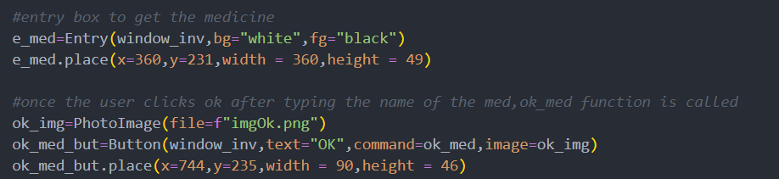

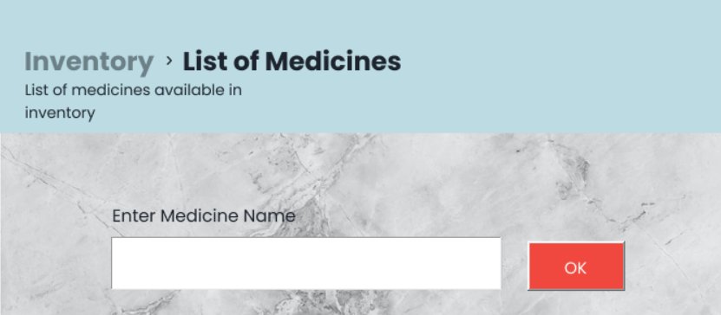

#2 Checking for the availability of the medicine:

* If the medicine entered is not present a suitable message is displayed
* If the medicine is present ,the expiry date of the medicine is checked against current date
* When the check for the medicine and its availability is finished ,an entry box e_quan receives the quantity of the medicine

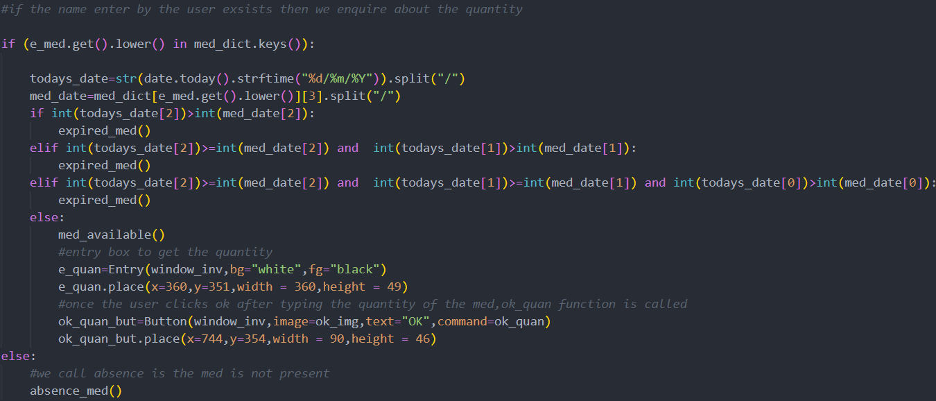

**Case 1**:Medicine entered not available

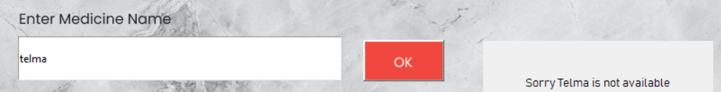

**Case 2** : Medicine entered is available but expired

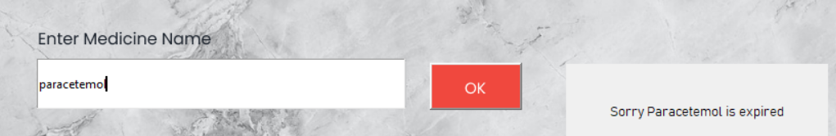

**Case 3**: Medicine entered is available

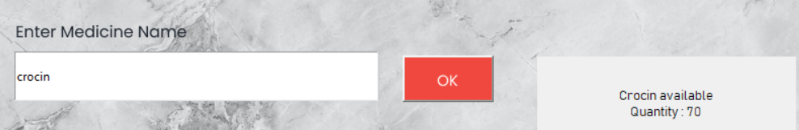

**Updating the database:**

* After performing the necessary checks the quantity user asked for is subtracted from the previously available stock
* To hold the data a hashtable is used



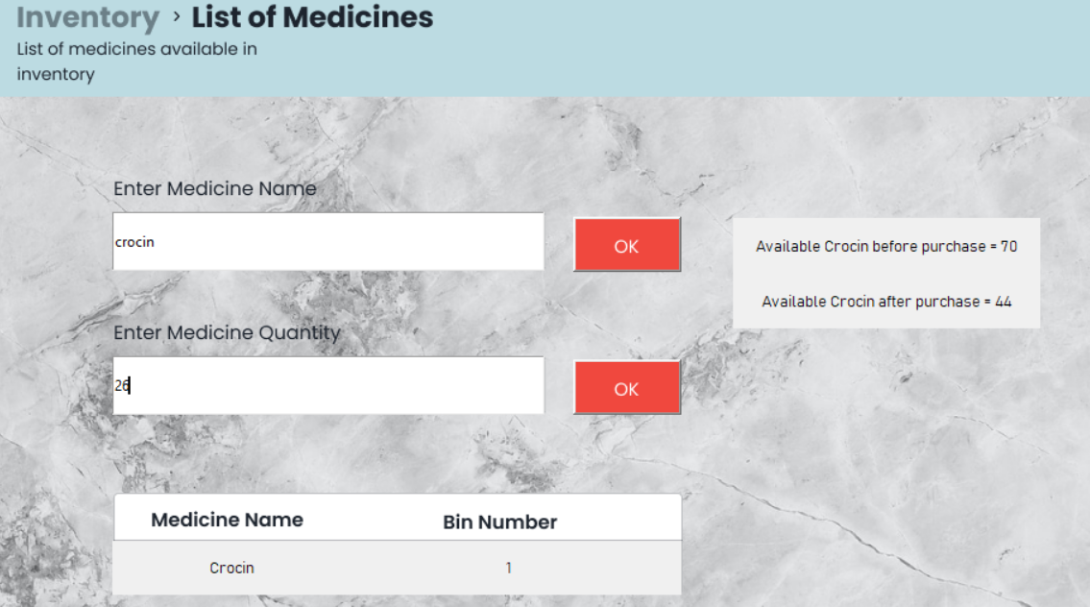

**Invoice related Code and Output:**

**Case 1 : No medicines are added**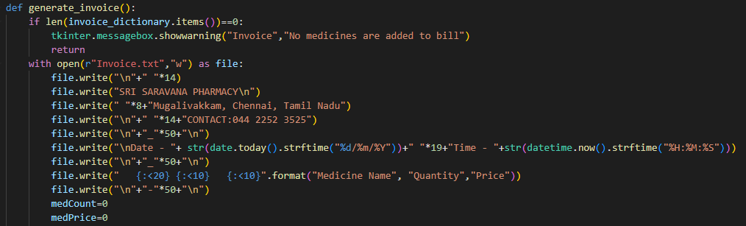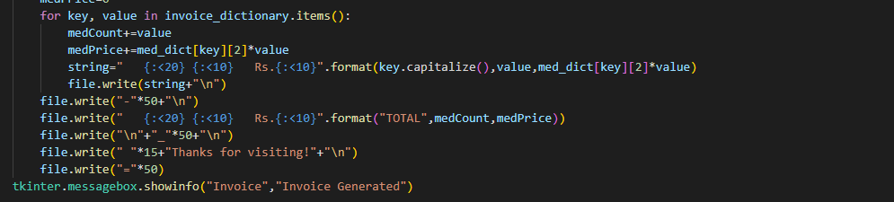

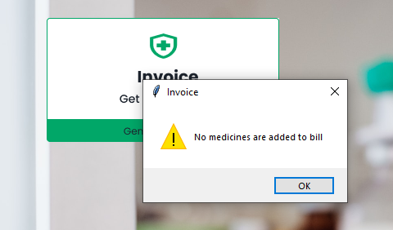

**Case 2 : Medicines are added**

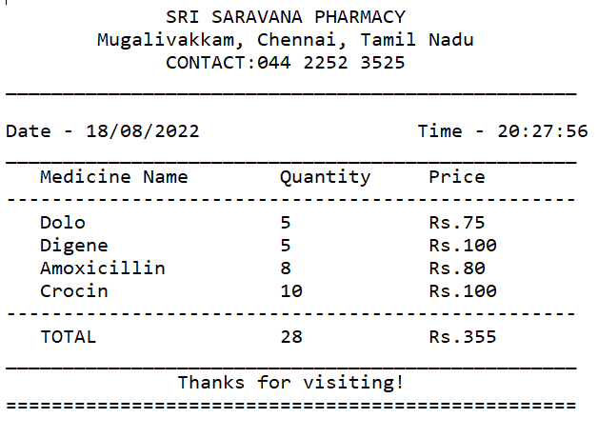

**Statistics related Code and Output:**

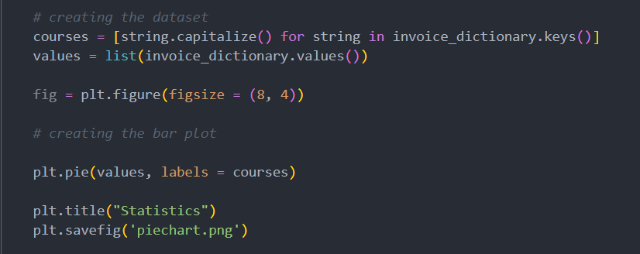

**Case 1:** No medicines are added

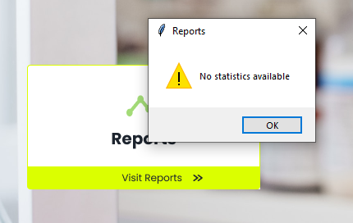

**Case 2:** Medicines are added

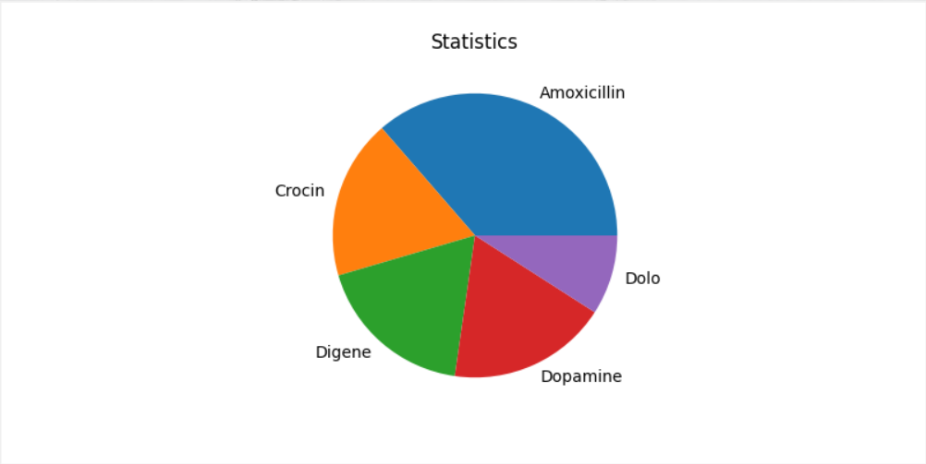

**Medicine Alerts related Code and Output:**

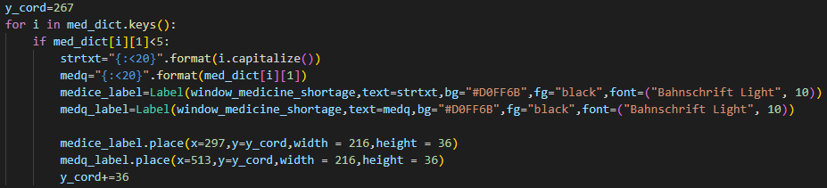

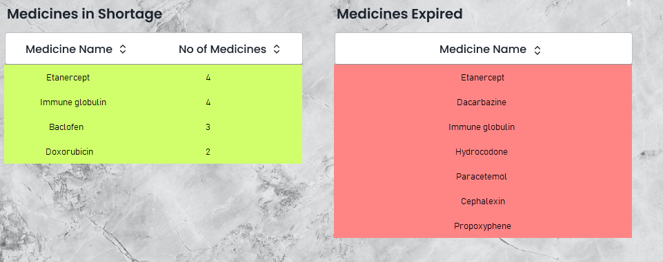

**CONCLUSION:**

It was very good to work with the project team

* There were many challenges while learning about Tkinter, Jira software
* Weekly targets were difficult to meet amidst the CATs and other assignments
* Initially we planned to use SQL for the database, later we were permitted to only implement on Data Structures which took us time

**FUTURE DIRECTIONS**

**CHALLENGES FACED:**

**1.Client :**

Searching for a client was a primary task for us, which took us nearly 2 weeks.

**2.Deadline :**

We had great issues with the deadlines which asked us to submit a weekly report of the progress

**3.Communication Problem:**

It took some period to get along with the team

**4.Breakdown:**

We had some issues with the time estimation since we didn’t break the tasks into smaller bits,then we sorted out that issue

**5.Data Storage:**

We first decided to have a CSV file type database since the department asked us to work with a pure python background we decided to have a Hashtable data structure for storing information temporarily

**6.Learning:**

As we are new to tkinter platform, it took us a while to cope up with it

**7.Templates:**

Getting templates for our application was a big task as we surfed through the net **8.Time estimation:**

As this is our first project to an actual client we had some rough time estimation that cost us a lot of time.

**What went right?**

1. We could collectively bring out every seven’s work into the project we have divided the work into a right matter which made all us to contribute and to force a lot of tasks on one’s back

2. We have done all the primary requirements that our client requested in a grandeur look.

3.Product have been delivered before the specified time given by the client which is a great achievement of our team.

**What went wrong?**

1.We couldn’t give a full screen size(1920*1080) which wasn’t a primary requirement.

2.We couldn’t give a pop up message which must contain the information regarding the which is about to expire and another pop up which contains information about the stock of the medicine which is about to go out of stock.

2.1We sorted out this issue by creating a terminal called Medicine shortage, which has two tables which contains information about medicines which are in shortage and expired medicines.This idea was confirmed by the client in the second scrum meeting.

.

3.We couldn’t generate the monthly ,yearly track record.But we have generated a daily sales track as it required a database to store the track record of monthly and yearly sales.

Lessons learnt

1. Learnt about the coworking environment.
2. Learnt about Tkinter which we used in designing our software.
3. Learnt about Agile and Scrum processes from Jira Software .
4. Learnt about data structures in an elaborate manner.

**What courses that should be learnt to make this a better product (releasable in public domain):**

Database management system required for keeping a record of the information for a longer time which would help in keeping track of the daily,weekly,monthly,annual sales.

Learning a more advanced GUI than tkinter for producing a better user interface.

**REFERENCES**

1.**Youtube**: We used Youtube to learn about tkinter which is the de facto way in Python to create Graphical User Interfaces (GUIs) and is included in all standard Python Distributions.

Some channels we referred to were freecodecamp and codemy.

2.**Atlassian** (Agile Coach): We used atlassian tutorials to deepen our agile knowledge with step by step tutorials that focus on a variety of topics related to Jira software.Basically ,Jira Software is an agile project management tool that supports any agile methodology, be it scrum, Kanban , or your own unique flavor.

3.**W3schools**: We learnt more about python using this website i.e using the documentation. We used this as a reference to learn more about the Matplotlib module.

4.**GeeksforGeeks**:We learnt more about date time modules,hashtables and how to use them in an effective manner on this website.

**CLIENT EVALUATION REPORT**

**Name of the project: PHARMACY MANAGEMENT SYSTEM**

**Team Members:** BALAKUMAR G

BHARATH KUMAR G

BHUVANESWARRAN T

DARRIEN XAVIER P V

DEEPESH SUDHAN A

DENNIS ANDREW B

DHANUSHPRIYAN P

**Client details:**

**CLIENT NAME:** Sri Saravana Pharmacy

**CLIENT LOCATION:** No.1/248,Mariamman Temple Street, Mugalivakkam Main Road, Chennai-600125

**CLIENT CONTACT:** Muthu,044 2252 3525

**Rating System - 1: Strongly disagree 2: Disagree 3: Neutral 4: Agree 5: Strongly Agree**

| **Questions** | **1** | **2** | **3** | **4** | **5** |
| --- | --- | --- | --- | --- | --- |
| **The problem was well discussed and the requirements and goals were clear.** |  |  |  |  |  |
| **The project plan was well defined and communicated from the start.** |  |  |  |  |  |
| **The resources were adequate for achieving the goals.** |  |  |  |  |  |
| **The original timeline was realistic and was followed.** |  |  |  |  |  |
| **The teamwork was well demonstrated.** |  |  |  |  |  |
| **The client was communicated on regular intervals and given updates on the progress of the project.** |  |  |  |  |  |
| **The expected project requirements have been satisfied.** |  |  |  |  |  |